**Hannah Green**

**E21**

**I & T - Implementation and Testing Unit**

**I.T 1 Take a screenshot of an example of encapsulation in a program.**

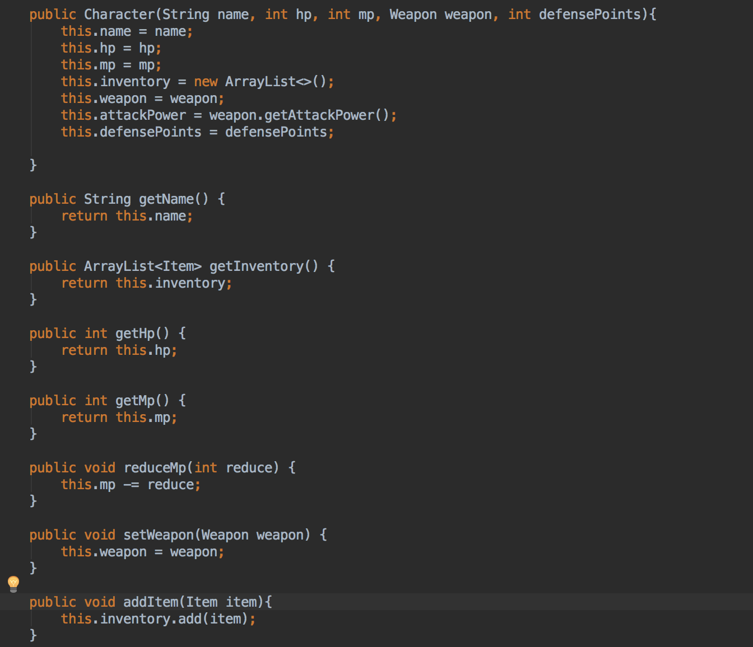

**I.T 2 Take a screenshot of the use of Inheritance in a program.**

● A Class



● A Class that inherits from the previous class

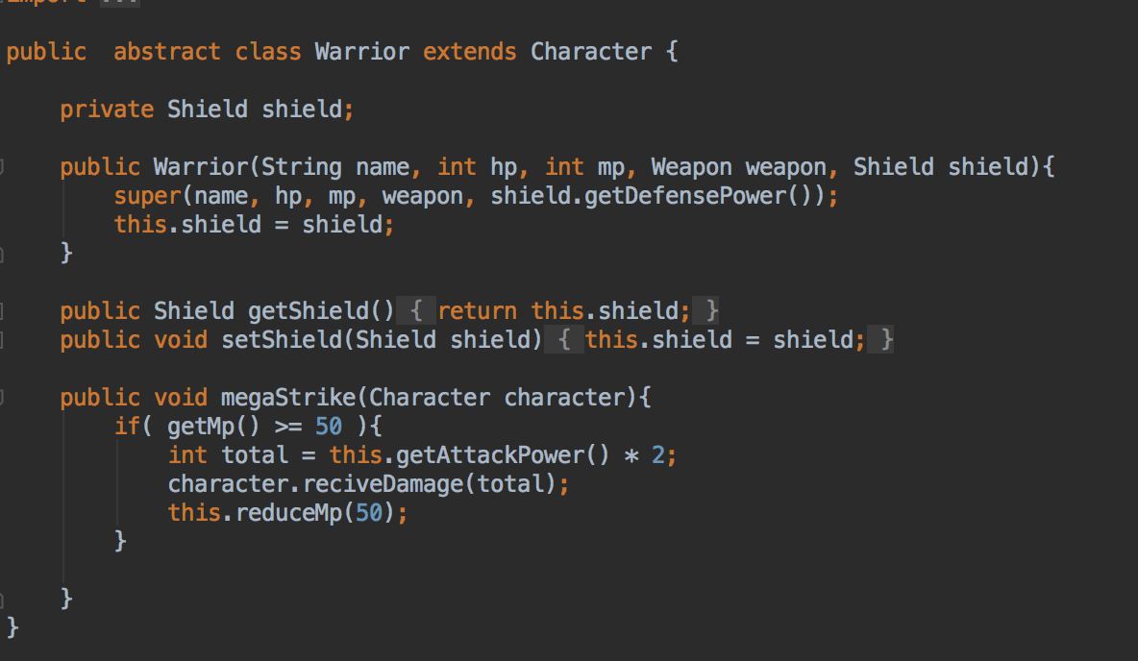

● An Object in the inherited class 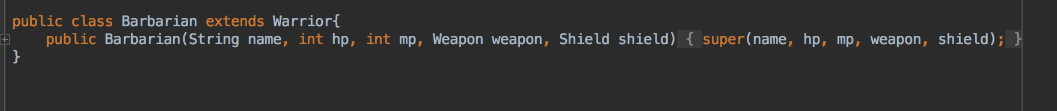

● A Method that uses the information inherited from another class.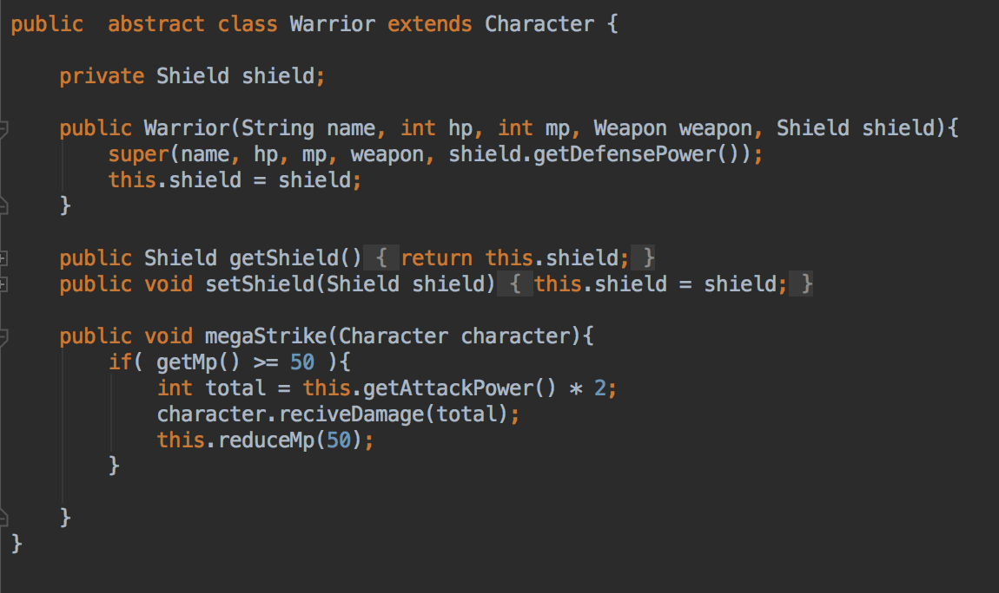

**I.T 3 Demonstrate searching data in a program.**

*● Function that searches data*

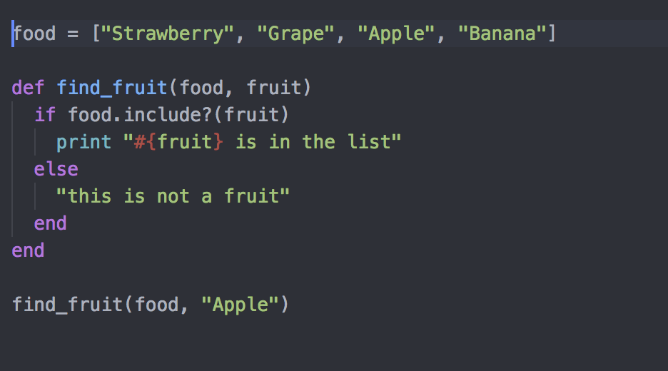

*● The result of the function running*

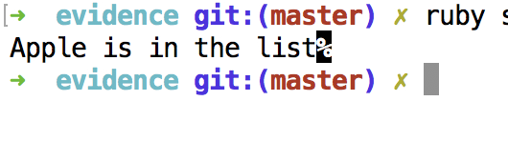

**I.T 4 Demonstrate sorting data in a program.**

*● Function that sorts data 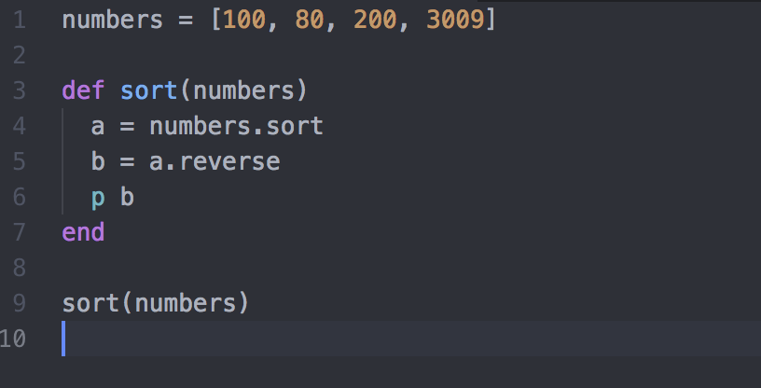*

*● The result of the function running*

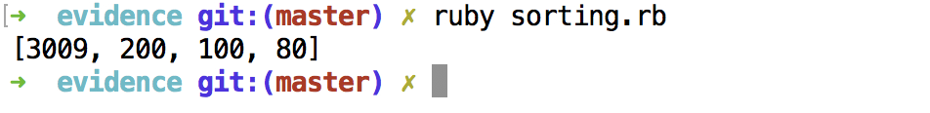

**I.T 5** Demonstrate the use of an array in a program.

*● An array in a program 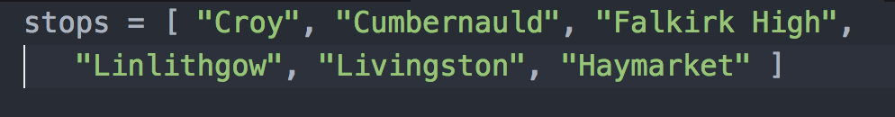*

*● A function that uses the array*

*● The result of the function running*

**I.T 6 Demonstrate the use of a hash in a program.**

*● A hash in a program*

*● A function that uses the hash*

*● The result of the function running*

**I.T 7 Demonstrate the use of Polymorphism in a program.**

